1.1
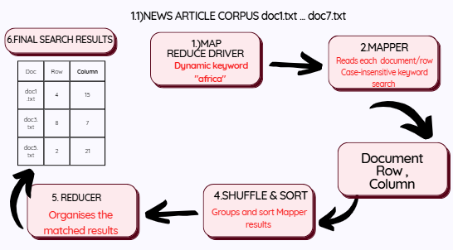
1.1 Keyword Search Using MapReduce
The MapReduce process is used to search for a specific keyword within the seven news article documents provided in the dataset. The keyword is entered dynamically by the user, for example, “africa”, instead of being permanently written into the program. The process consists of the Mapper, Shuffle and Sort, and Reducer stages.
First, the Driver reads the seven text documents and separates each document into individual rows. The selected keyword is then passed to the Mapper. The Mapper searches each row of every document for the keyword. The search is case-insensitive by converting both the keyword and the text to lowercase. When the keyword is found, the Mapper records the document name, row number and column position of the match.
The Mapper results are then passed through the Shuffle and Sort stage. This stage organises the results according to the document, row and column. The Reducer then processes the organised results and produces the final list of keyword locations.
The expected output identifies the document in which the keyword was found, together with the row and column position. For example:
Document: doc1.txt | Row: 4 | Column: 15
Document: doc3.txt | Row: 8 | Column: 7
Document: doc5.txt | Row: 2 | Column: 21
Therefore, the MapReduce process allows the keyword to be searched efficiently across multiple documents while providing the exact location of each occurrence.

1.2
For this part of the project, I created an RStudio file called mapper.R to perform the Mapper stage of the MapReduce process. The Mapper reads each line from the news article documents and searches for the keyword entered by the user. The keyword is converted to lowercase before searching, which allows the program to identify the keyword regardless of whether it is written in uppercase, lowercase, or a combination of both. When a match is found, the Mapper records the document name, row number and column position where the keyword occurs. These results are then stored in a data frame and passed to the Reducer for further processing. The Mapper was tested as part of the complete RStudio project using the seven text documents provided.
1.3
For the Reducer stage, I created a separate RStudio file called reducer.R. The Reducer receives the results produced by the Mapper and organizes them by document, row and column. This makes the keyword matches easier to read and ensures that the results are presented in an organized order. If no matches are found, the Reducer returns an empty result instead of producing an error. I also created a driver.R file in the RStudio project, which connects the Mapper and Reducer and allows the complete MapReduce process to run from beginning to end. The Driver also allows the keyword to be entered dynamically and saves the final search results to a CSV file.

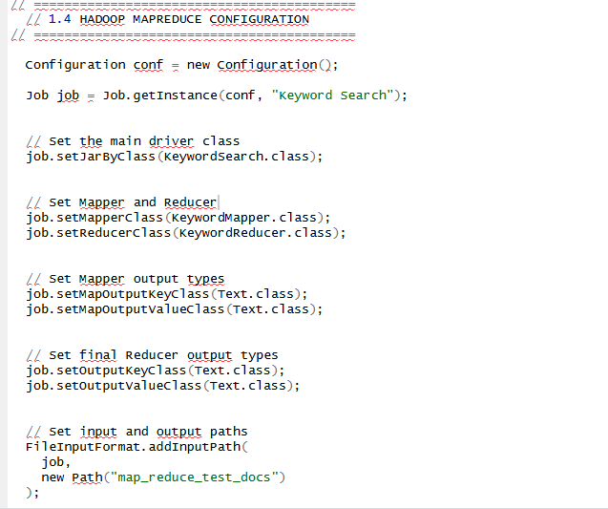
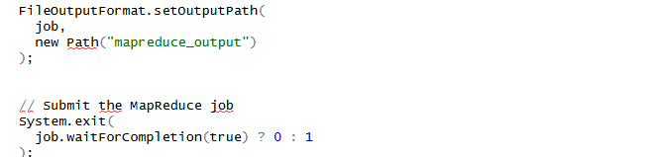

Question 2

1.1

Installing packages
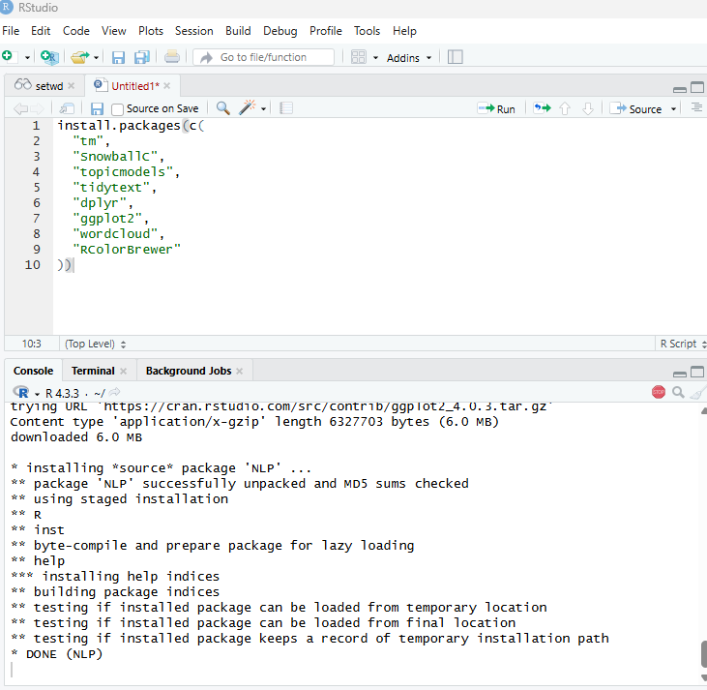
Loading libraries
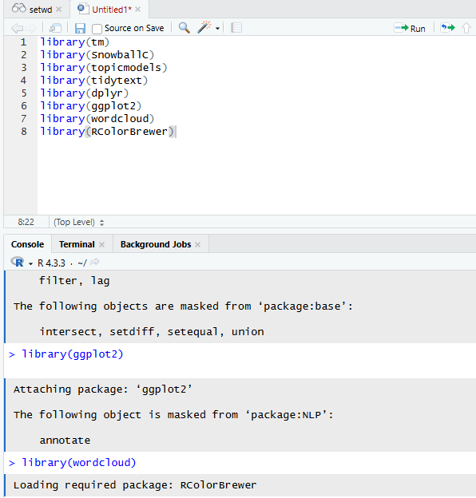

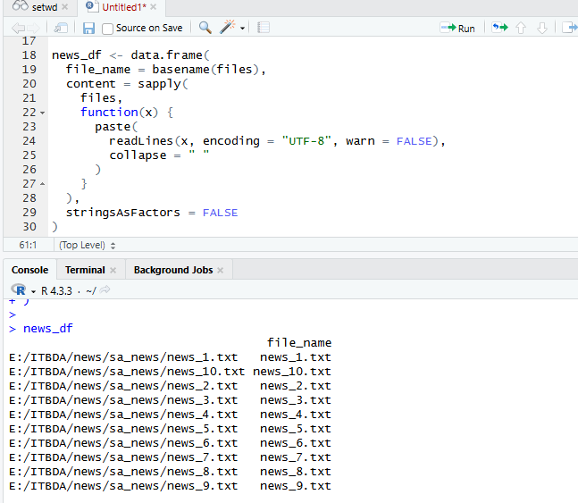
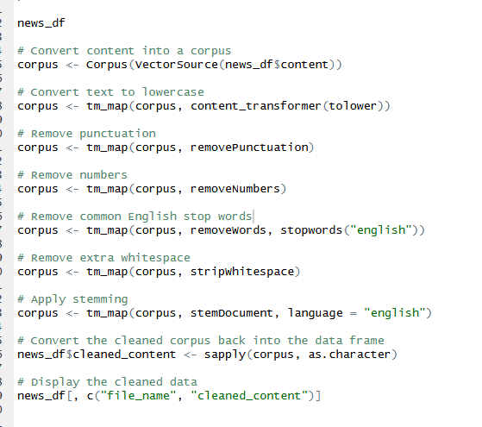
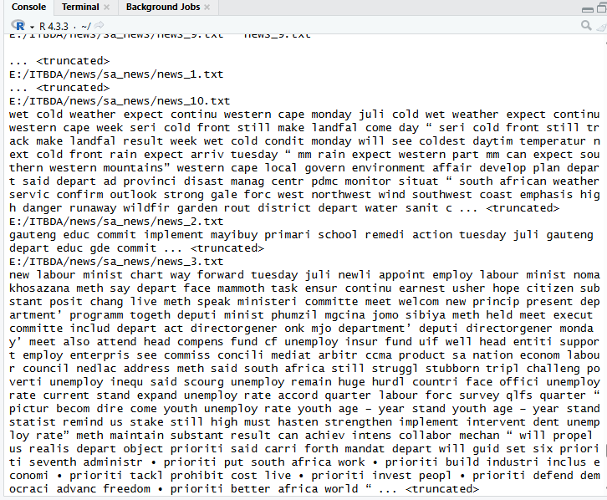
2.2
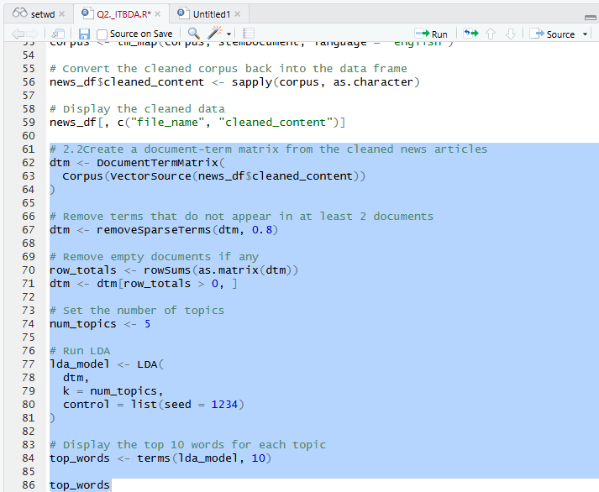
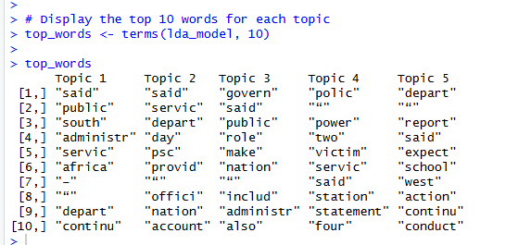

The code creates a Document-Term Matrix from the cleaned news articles and applies Latent Dirichlet Allocation (LDA) to identify five main topics. The model then extracts the 10 most important words associated with each topic. The output shows the top words for each topic, with words such as “public”, “service”, “government”, “department”, “school” and “polic” appearing frequently. These words provide an indication of the main themes discussed across the news articles and will be used to interpret the topics and their word distributions.

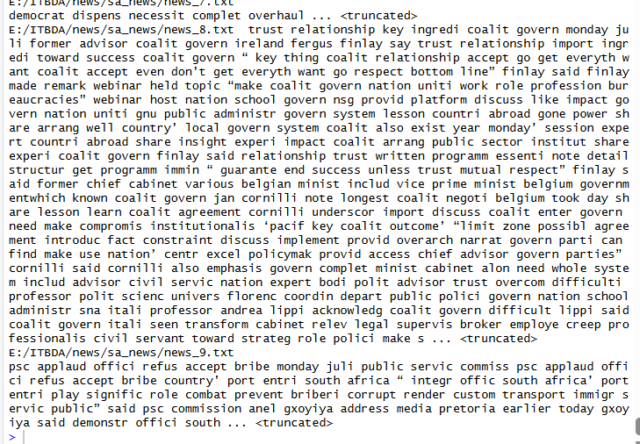

The output shows that the 10 South African news files were successfully loaded into a data frame containing the file name and article content. The text was then preprocessed by converting it to lowercase, removing punctuation, numbers, stop words and extra spaces, and applying stemming. The cleaned_content column shows the processed text, where words have been reduced to their root forms. This prepares the news articles for further text analysis and topic modelling in the next questions.

2.3)

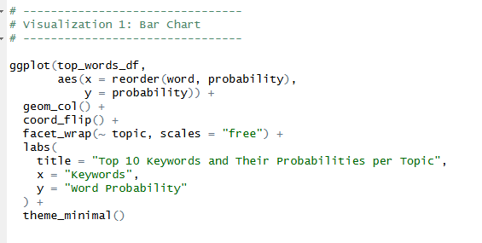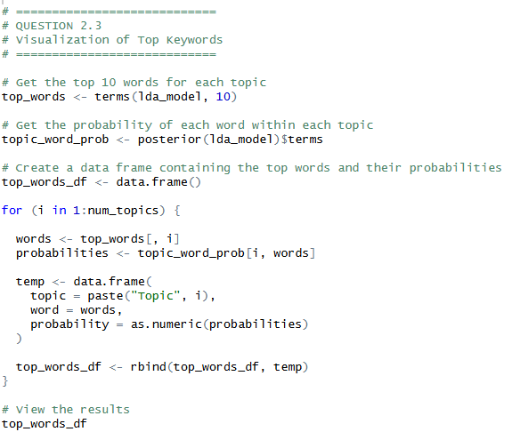
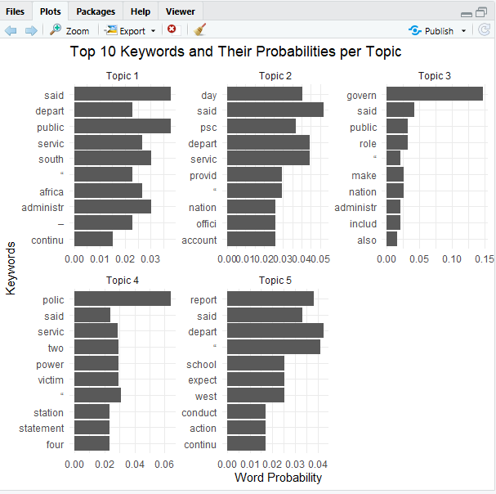
The bar chart shows the top 10 key words associated with each of the five LDA topics and their corresponding word probabilities. The probability indicates how strongly each word is associated with a particular topic. Higher probabilities represent words that are more representative of the topic. The results show that the news articles contain several recurring themes, particularly relating to government, public services, departments, administration, education, and industry.

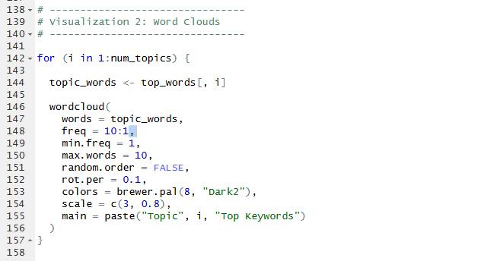
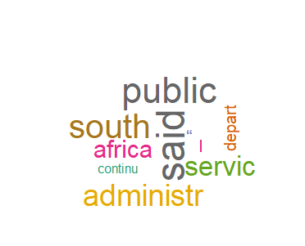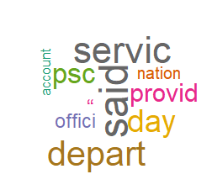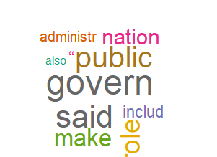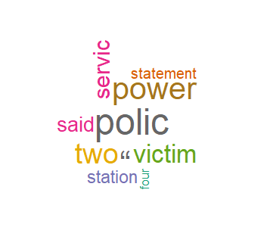

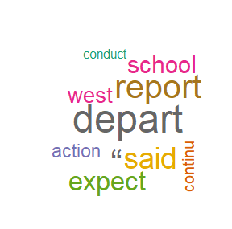
The word clouds provide a visual representation of the most prominent keywords within each topic. The results show that the news articles mainly focus on themes related to government, public services, administration, departments, and South Africa. Words such as government, public, administration, department, official, and statement suggest discussions about government activities and public-sector matters. Other keywords such as power, police, victim, and station indicate topics related to public safety and incidents, while words such as school, report, conduct, and action suggest discussions related to education and departmental activities. Overall, the word clouds show that the identified topics are centred around government and public services, with additional themes involving policing, power, education, and public affairs.

Question 3
3.1 ) Web scrapping data frame
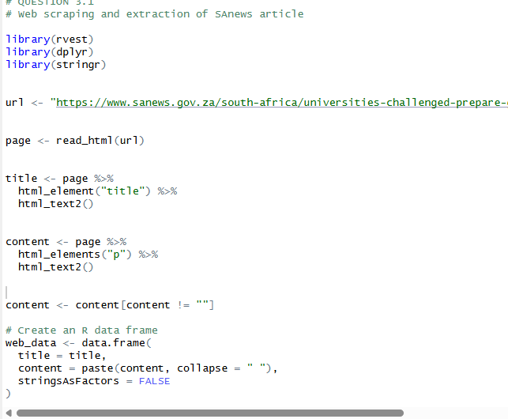
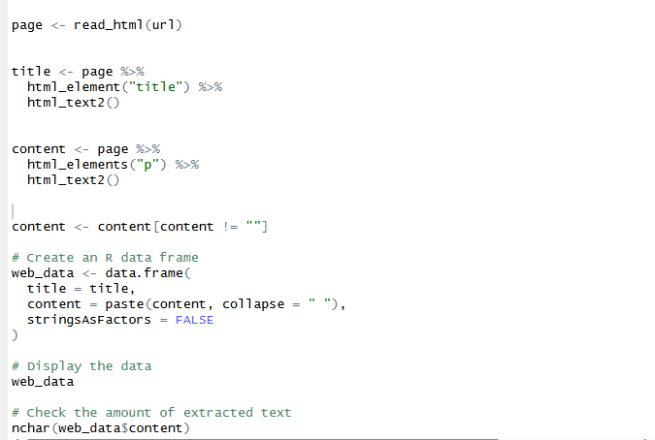
Output

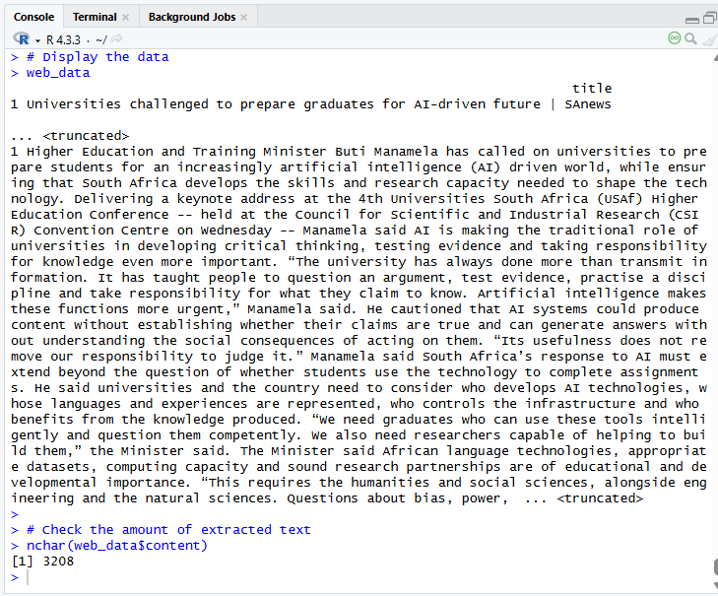
3.2 Preprosessing
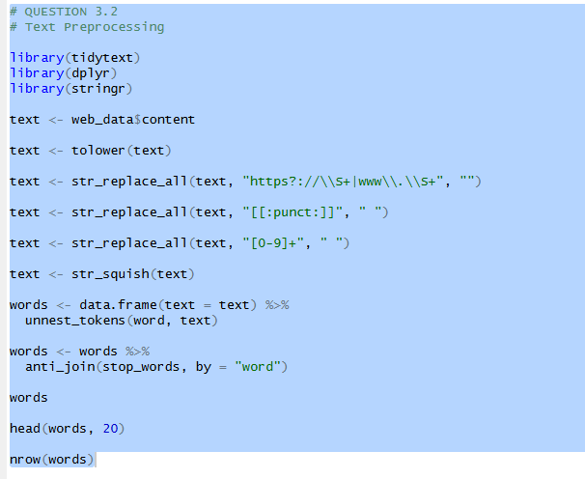
Outputs
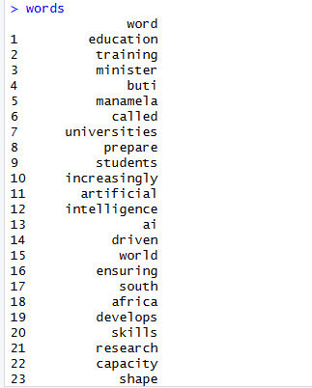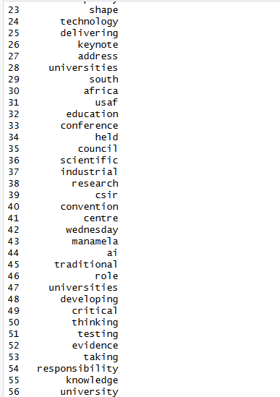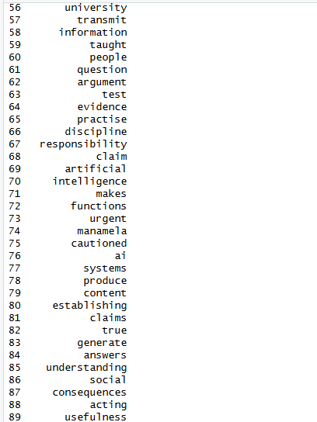
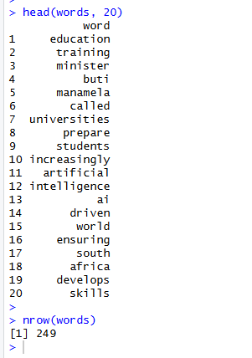
The extracted article was preprocessed to remove unnecessary information and prepare the text for analysis. The text was converted to lowercase, URLs, punctuation, numbers, and extra spaces were removed, and the content was separated into individual words. Common English stop words and irrelevant website information were also removed so that the analysis could focus on the meaningful words in the article.

3.3
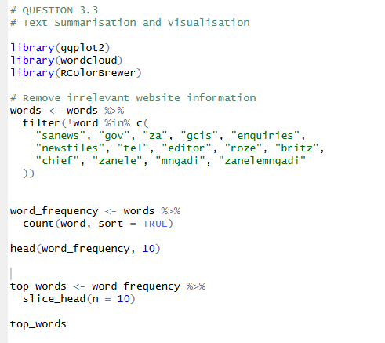
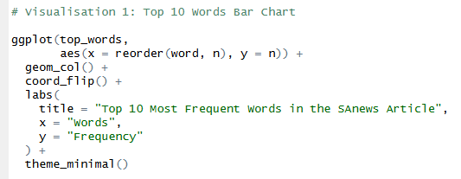
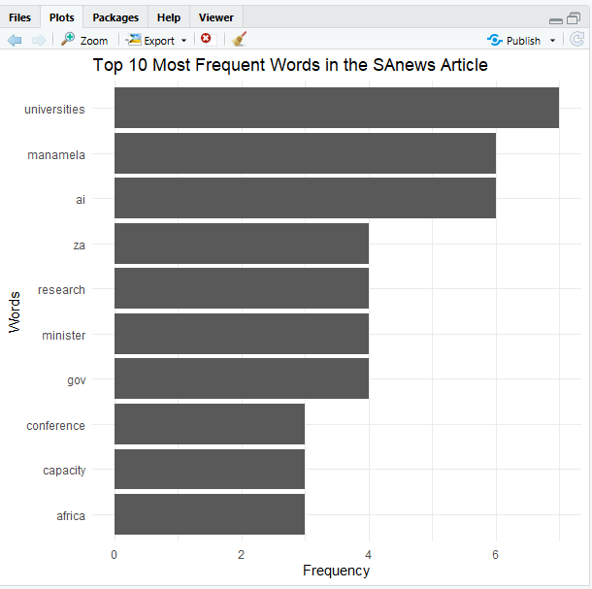

The bar graph shows that “universities” is the most frequent word, appearing 7 times, followed by “AI” and “Manamela”, which each appear 6 times. Other frequent words include “minister”, “research”, “Africa”, “capacity”, and “conference”. This shows that the article mainly focuses on universities preparing for AI, research capacity, and the development of skills in South Africa.
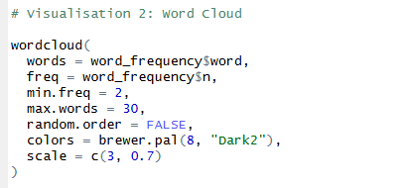

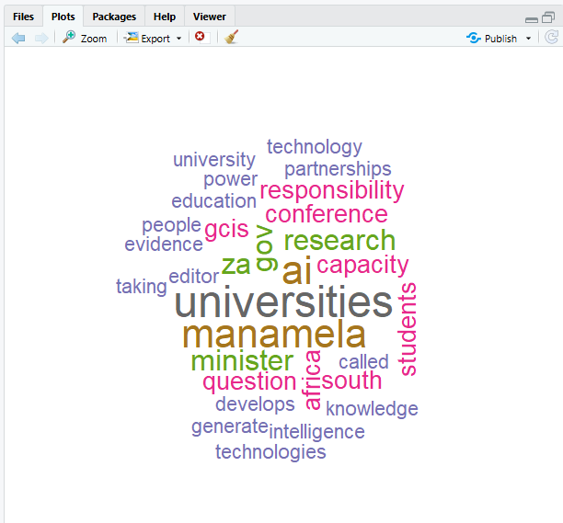
The word cloud highlights the most frequently used words in the article, with larger words appearing more often. The prominent words include “universities”, “AI”, “research”, “Africa”, “students”, and “technology”. This indicates that the main themes of the article are higher education, artificial intelligence, research, and preparing students for the future.

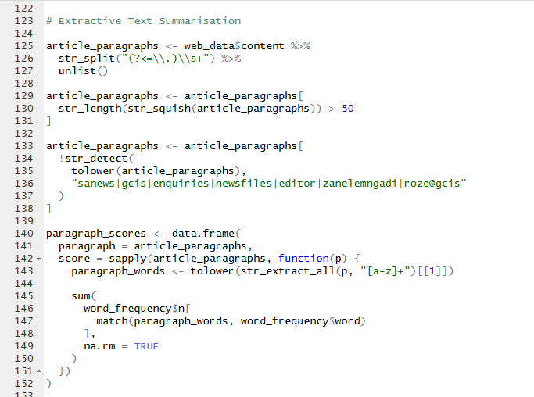
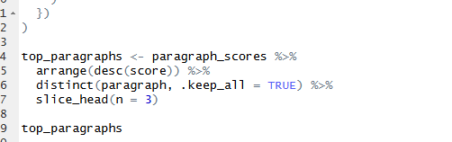
The first summarization technique used was word-frequency analysis. The most frequent words were “universities” (7), “AI” (6), “Manamela” (6), “minister” (4), and “research” (4). These results show that the focus of the article is the role of universities in preparing students for an AI-driven future. The frequent words also highlight the importance of research, skills development, and the use of AI in South Africa.
The second summarization technique was extractive summarizations. The three highest-scoring text sections focused on preparing universities and students for AI, maintaining the quality of university qualifications, and developing critical thinking and research capacity. This shows that universities need to adapt to AI while continuing to develop important academic and critical-thinking skills.
South Africa. Overall, the summarizations and visualizations show that the article focuses on how higher education should prepare for the increasing influence of artificial intelligence.

Question 4
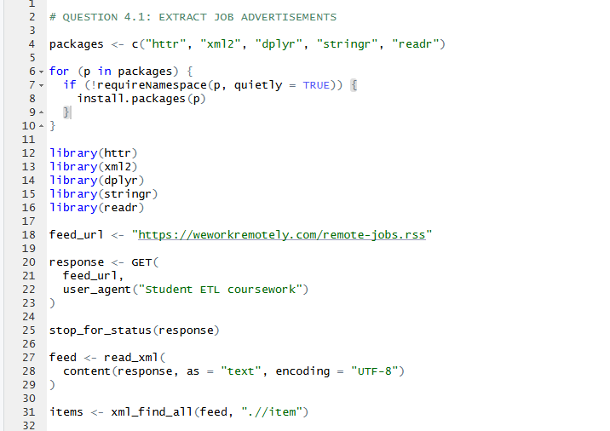
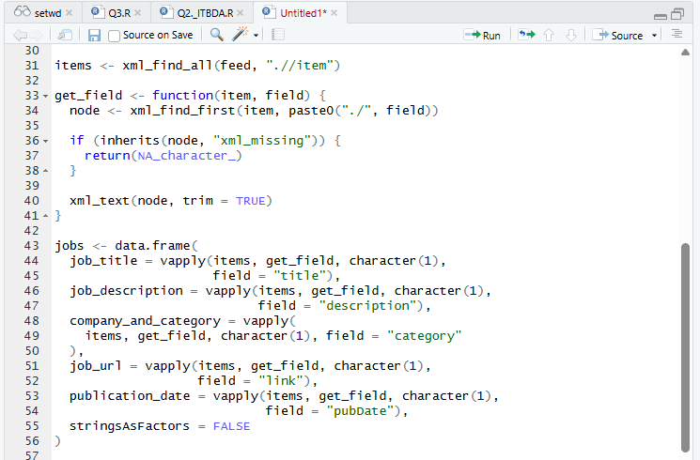
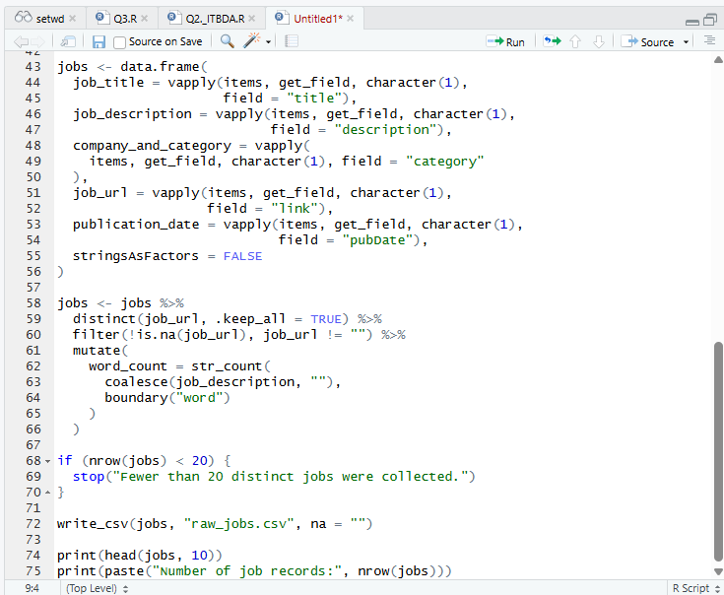
The purpose of this task was to develop an ETL process for collecting job advertisement data from a website using R. The We Work Remotely website was selected as the data source, and its public RSS feed was accessed using the httr package. The xml2 package was used to read and extract the information from the feed, while dplyr and stringr were used to organise and process the extracted records. The resulting data frame contained job titles, job descriptions, company and category information, publication dates, and job URLs. A numerical attribute, word_count, was also created to calculate the number of words in each job description. The raw dataset was then exported to a CSV file named raw_jobs.csv for further processing.

Output
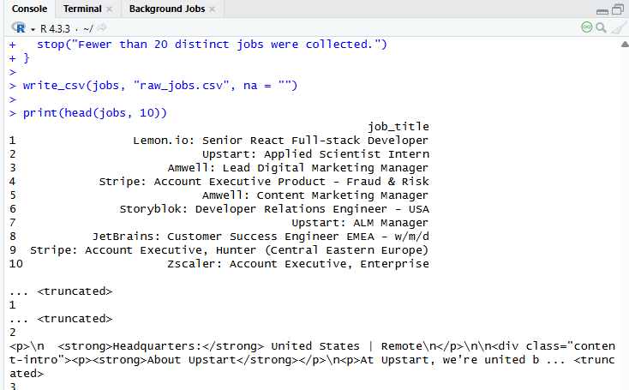
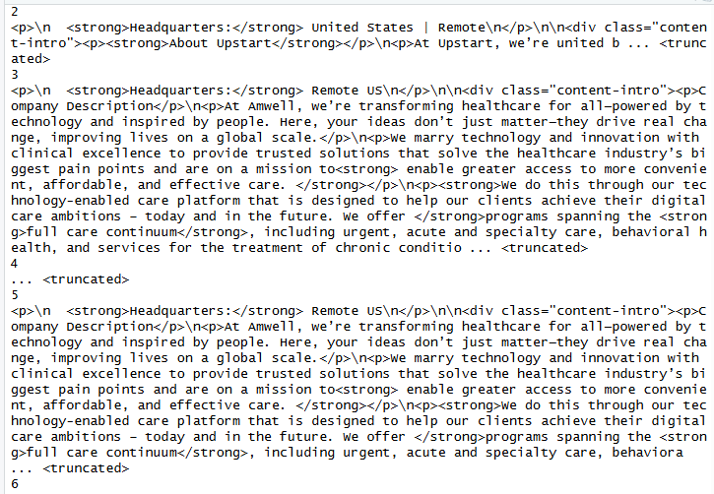
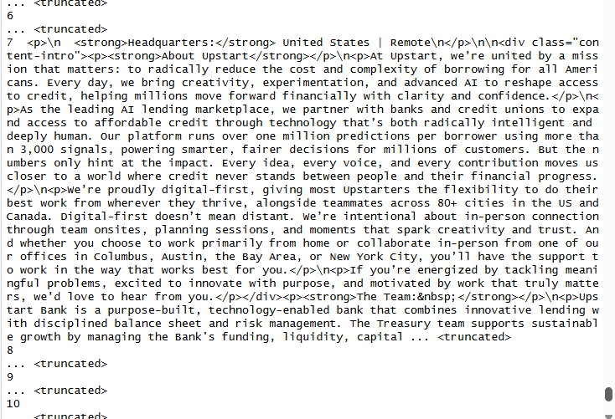
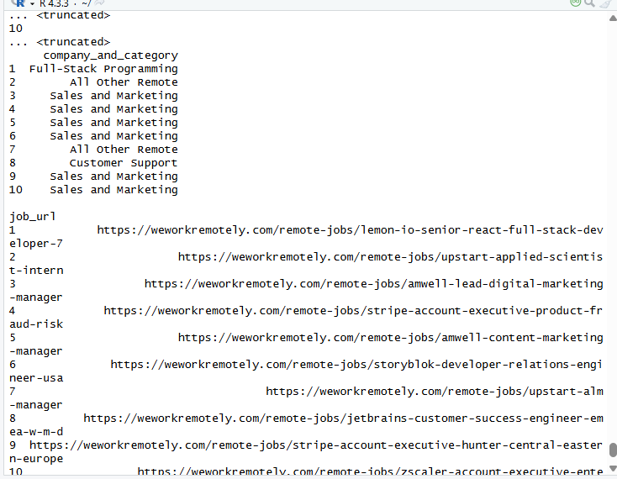
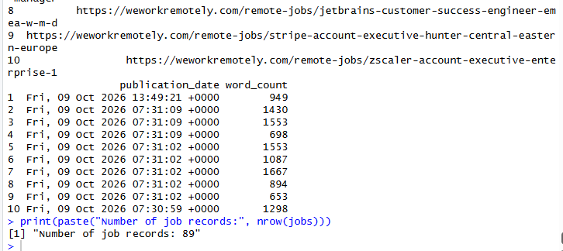
The output showed that 89 distinct job advertisements were successfully collected, exceeding the minimum requirement of 20 records. The extracted data included different job positions, such as Senior React Full-stack Developer, Applied Scientist Intern and Lead Digital Marketing Manager. The word counts ranged from 653 to 1,667 words among the first ten records displayed, demonstrating that the descriptions varied in length. The output also revealed that the job descriptions contained HTML tags and formatting elements, indicating that further cleaning would be necessary before analysis. Overall, the extraction stage successfully converted web-based job advertisement information into a structured R data frame containing both textual and numerical attributes.

4.2)
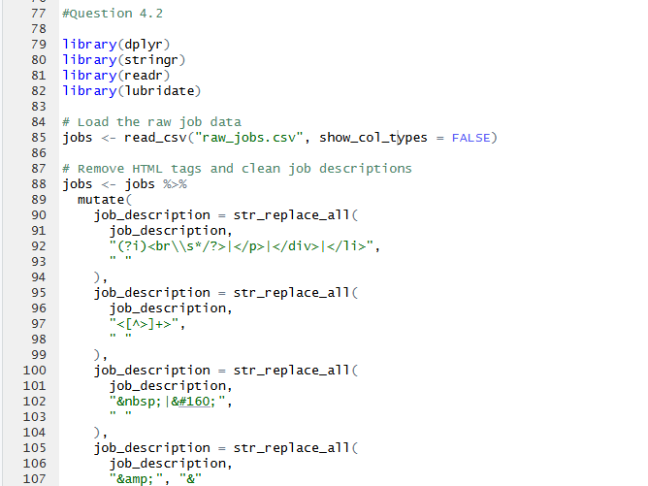
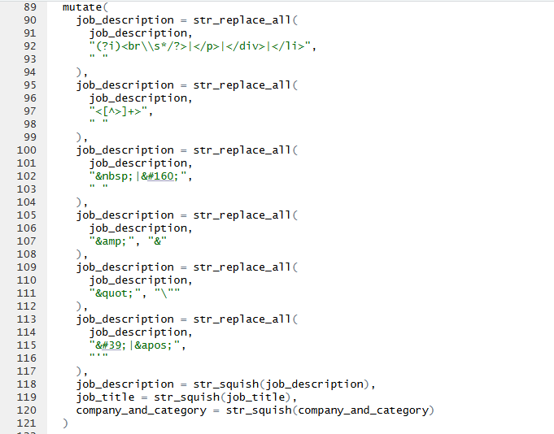
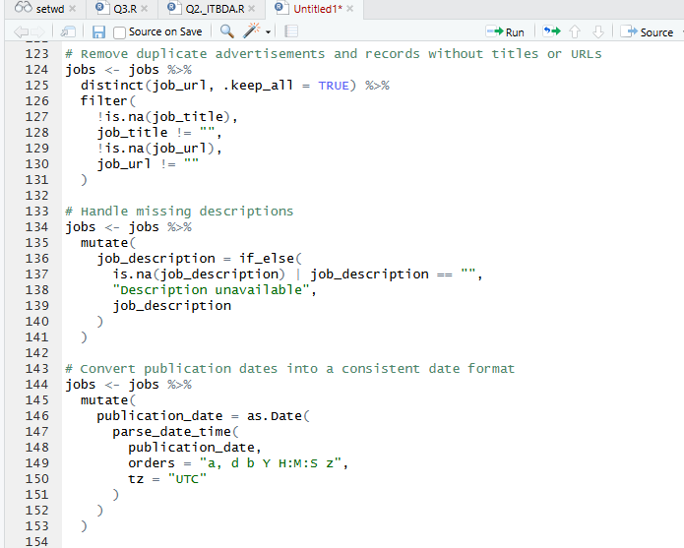
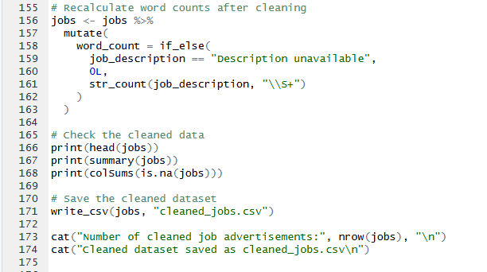
In Question 4.2, the raw job-advertisement dataset was cleaned and transformed using R. HTML tags and unwanted formatting were removed from the job descriptions to make the text easier to read and analyse. Extra spaces were corrected, duplicate advertisements were removed using the job URL, and records without a valid job title or URL were excluded. Missing job descriptions were replaced with a placeholder value, while publication dates were converted into a consistent date format. The word counts were also recalculated after cleaning to reflect the number of words in each cleaned job description.

Output
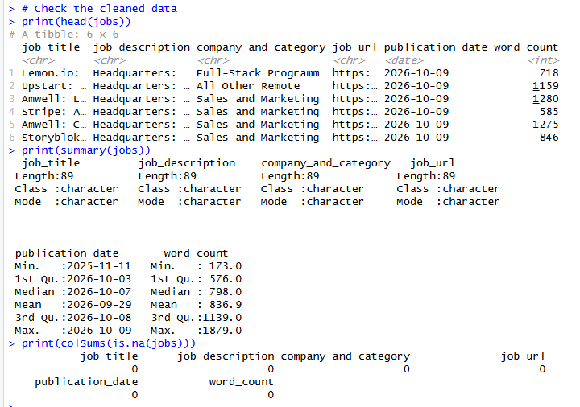
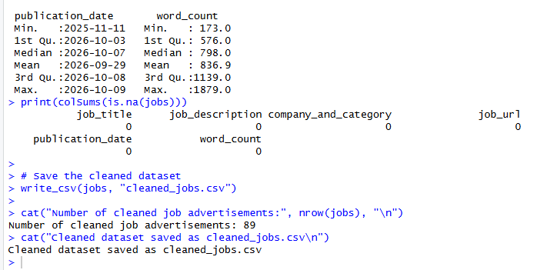
The output showed that 89 job advertisements remained after cleaning. The summary statistics indicated that the publication dates ranged from 11 November 2025 to 9 October 2026, while the word counts ranged from 173 to 1,879 words, with an average of approximately 837 words per advertisement. The missing-value check confirmed that all six columns contained zero missing values. Finally, the cleaned dataset was saved as cleaned_jobs.csv, preserving the original raw_jobs.csv file and preparing the processed data for the next stage of the ETL process, which involves loading the data into PostgreSQL.

4.3)
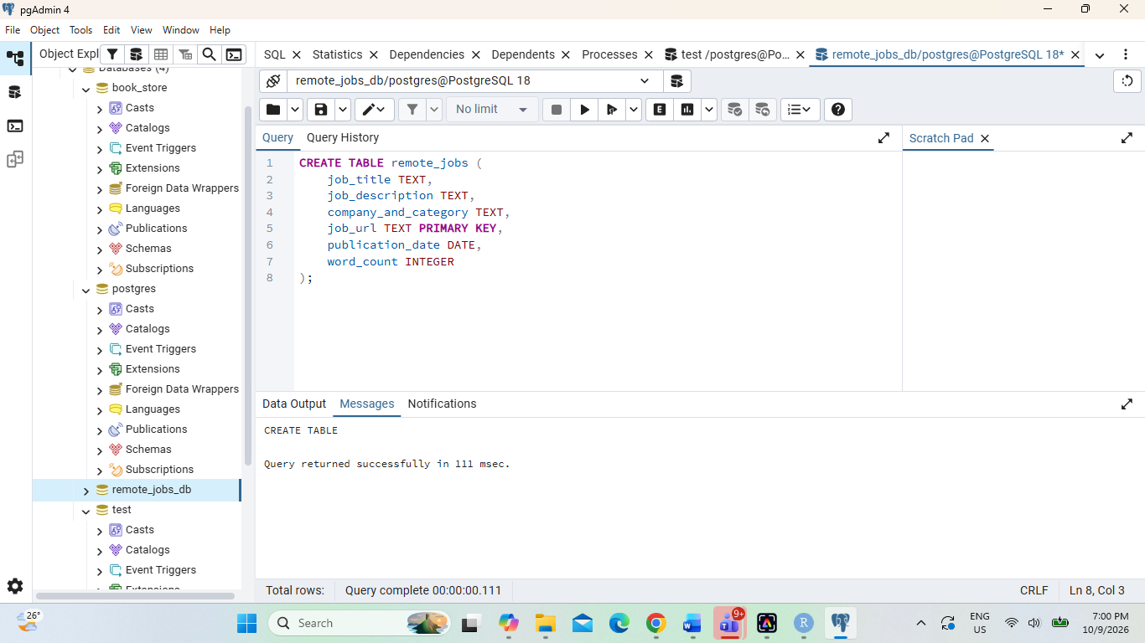

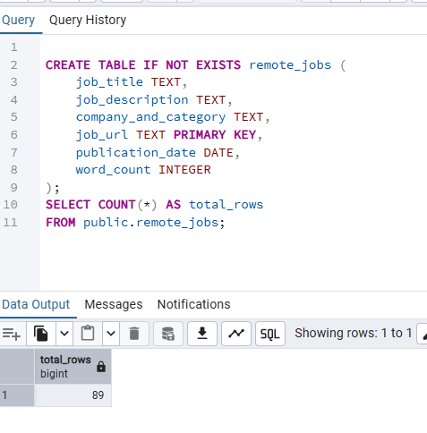

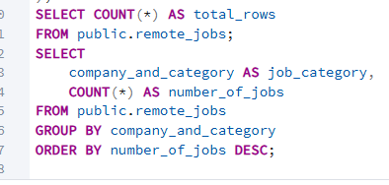
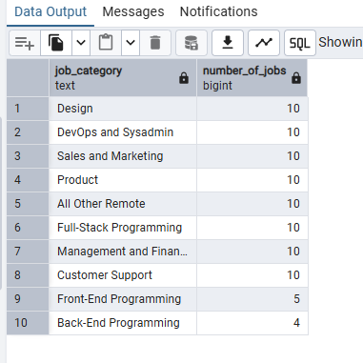

Analysis 1: Distribution of Job Advertisements by Category
The first SQL analysis examined the distribution of remote job advertisements across different job categories using the GROUP BY and COUNT() functions.
The results showed that Design, DevOps and Sysadmin, Sales and Marketing, Product, All Other Remote, Full-Stack Programming, Management and Finance, and Customer Support each had 10 job advertisements. Front-End Programming had 5 advertisements, while Back-End Programming had the lowest number, with 4 advertisements. These results indicate that the dataset contains more advertisements in certain categories than others. This analysis helps identify which remote job categories are most represented in the collected data.

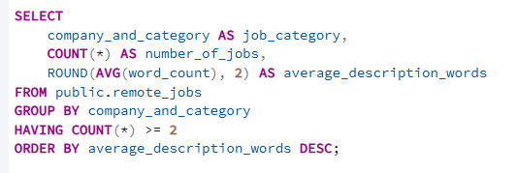
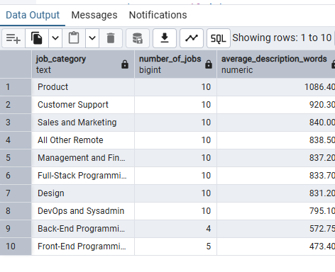

Analysis 2: Average Word Count of Job Descriptions by Category
The second SQL analysis compared the average word count of job descriptions across different categories using the AVG() function.
Product had the highest average description length, at approximately 1,086.40 words, followed by Customer Support at 920.30 words and Sales and Marketing at 840.00 words. All Other Remote had an average of 838.50 words, followed by Management and Finance at 837.20 words, Full-Stack Programming at 833.70 words, and Design at 831.20 words. DevOps and Sysadmin had an average of 795.10 words. Back-End Programming and Front-End Programming had lower averages of 572.75 and 473.40 words, respectively. These findings suggest that job descriptions in the Product category contain more words on average, while Front-End Programming descriptions are shorter. This analysis demonstrates how SQL can be used to summarise and compare numerical information across job categories.

4.4 Creating repository
